POWER CONVERSION CARD

Hardware Requirement Specification
Rev-C

15-JUL-14

Ownership Disclaimer
Copyright © 2011 by Compressor Controls Corporation. All rights reserved.
This document contains proprietary and confidential material that is the sole property of Compressor Controls Corporation. The information contained herein is intended for internal use by Compressor Controls Corporation employees and is not intended for distribution outside of the company. As an unpublished work of trade secrets, the recipient shall keep this document confidential. Any re-use, copying, or distribution, either in whole or in part, of this material without the express written consent of Compressor Controls Corporation is strictly forbidden.

Revision History

Rev. | Date | Revised By | Description
REV B | 2-May-2013 | Manjunath M
REV C | 15- Jun- 2014 | Muthuvelu D

Approvals

Approved by: Date: _______________
Approved by: Date: _______________
Approved by: Date: _______________
Approved by: Date: _______________
Approved by: Date: _______________
Approved by: Date: _______________

TABLE OF CONTENTS

1 Introduction 4
1.1 Purpose 4
1.2 Audience 5
1.3 Scope 5
1.4 Acronyms 5
1.5 References 5
2 General Description 6
2.1 System Overview 6
2.2 Product Functions 7
2.3 Block Diagram 8
3 Electrical Requirements 9
3.1 Input Requirement 9
3.2 Output Requirement 9
3.3 Intermediate Requirement 9
3.4 I2C Interface Requirement 9
3.5 Diagnostic Requirement 10
3.6 Hot swap Requirement 10
3.7 Board Indicator Requirement 11
3.8 Redundancy Requirement 11
3.9 Digital Supply Requirement 11
3.10 Protection Requirement 11
3.11 PCC- IES Communication Requirement 12
3.12 Front Panel LEDs 12
3.13 Components 12
3.14 Connectors 12
4 Mechanical Requirements 13
4.1 PCB Form Factor 13
4.2 PCB Thickness 13
4.3 Component Height factor 13

Introduction

Purpose
The purpose of this document is to capture the hardware requirements for PCC card (Power Conversion Card) which is used as main powering unit on New Generation Platform (NGP) control system.

Audience
This document is meant to be used by the project team members as the basis and controlling document for the design and development of PCC card.

Scope
Power Conversion Card is a main power conversion card based on DC-DC Controller design which will be used as power supply unit t for New Generation Platform control system. This document defines the product requirements to which hardware has to be designed and manufactured. This document also covers system level requirements applicable to PCC card. This document doesn’t cover the firmware/ software related requirements.

Acronyms
Acronym | Definition
APP | Application Processor Card
I2C | Inter IC
IC | Integrated Circuit
IES | Integrated Ethernet Switch
IOP | Input Output Processor
NGP | New Generation Platform
PCB | Printed Circuit Board
PCC | Power Conversion Card
RoHS | Restriction of Hazardous Substances

References
[1] Detailed Functional Specification for NGP Hardware, Part 1, Rev-3
[2] System Study for New Generation Platform Electronics and Bring-up, Rev-1
[3] LTC4364, LTC3890 datasheet from linear technology.

General Description

System Overview
New Generation Platform (NGP) is a fully redundant, duplex, highly available, fault tolerant control system intended to handle a number of digital, analog and frequency IOs in industrial applications. Below is the system block diagram of NGP.

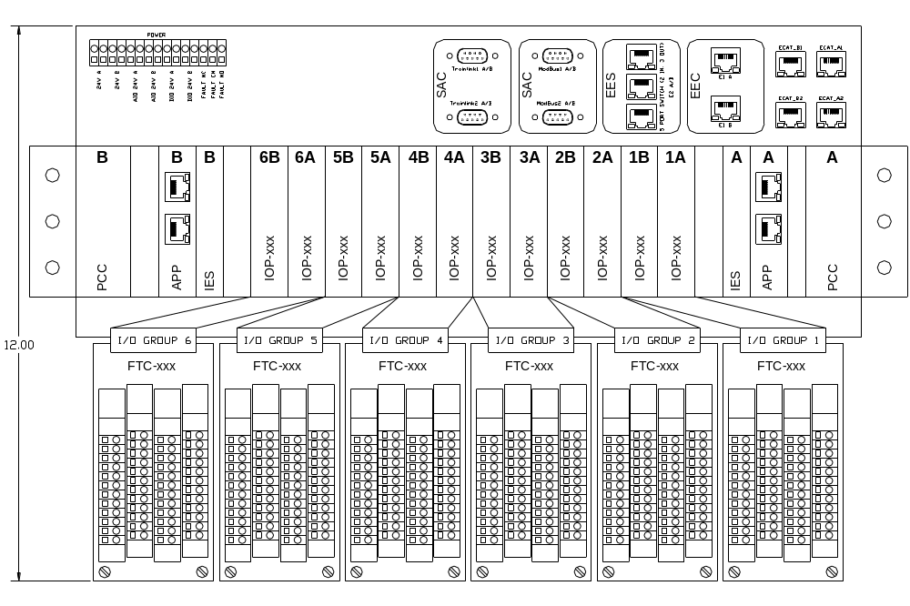
Here is the list of different electrical components in the system and their brief description.

APP
This is the main processing unit in the system. This runs the main application and does monitoring and control of the overall system. There will be a maximum of 2 such cards in an NGP system.

IOP (Digital and Analog)
These are the processors cards which handle digital, analog and frequency IOs. There will be a maximum of 12 such cards in an NGP system.

IES
This is the EtherCAT switch card used to interface between different APP and IOP modules. There will be a maximum of 2 such cards in an NGP system

PCC
This is power conversion card. The input power (redundant 24VDC) to the system first comes to this card. This card does the oring, filtering, protection and other voltage conversion. There will be a maximum of 2 such cards in an NGP system

FTC (Digital and Analog)
These ate the field terminal cards where all the field loads are connected to. These are electrically interfaced to IOP cards. The number of FTC in an NGP system is same as the number of IOP card

CAC
These are the set of communication (Ethernet, RS-485) cards used for interface to the external devices

Backplane
All the above mentioned boards plug in backplane and communicate to each other over it.

Product Functions
PCC is the main power supply card for NGP System. The product receives the two different 24V DC power rails from external world. Incoming 24V power buses are Hot swapped , ORed inside the PCC card and 24V to 6.5V DC-DC conversion would be taken place on board with capability of 6.5V @25A and supporting 24V @8A. Boards also have diagnostic LEDs and I2C communication with IES Board.

Block Diagram

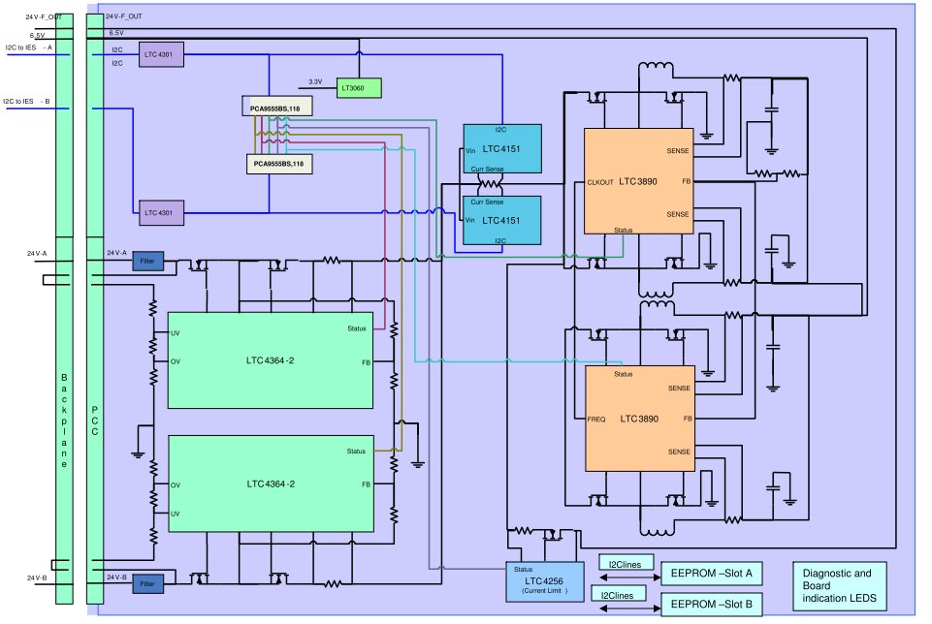

Electrical Requirements

Input Requirement
    - PCC card shall power up entire NGP system.
    - PCC Card shall accept 18V -32V as an external DC input Voltage.
    - The nominal input voltage shall be 24V DC.
    - The PCC card shall accept two input rails from the back plane, namely 24V_A and 24V_B.
    - PCC shall make use of common reference available to the NGP platform ( Single grounding system).

Output Requirement
    - PCC board shall be able to deliver 6.5V@25A continuously.
    - Card shall be able to power conversion (DC-DC) with non isolated ground approach.
    - Card shall be able to handle power conversion without any external heat sink and board itself shall act as a heat sink.
    - Card shall be able to provide 24V_Filtered_Out @ 6A and shall be able to provide a short circuit protection on this power bus.

Intermediate Requirement
    - There shall be a provision to measure the power on the major power bus( ORed 24V )
    - There shall be provision to measure the input voltage and read it through digitally.
    - There shall be requirement to measure on board temperature of the PCC card.
    - The temperature measurement shall be minimum of ± 1 ° accuracy.
    - PCC Card shall have EEPROM to store the board information.
    - The EEPROM used shall have 2K Bit memory capacity and shall have I2C combination interface.

I2C Interface Requirement
    - PCC Card shall have single I2C line communication with IES Board Processor.
    - PCC Card shall have an I/O Expander which should talk to PCC card I2C Devices internally.
    - I2C Line shall be shared between the following devices on PCC :
- On Board Temperature sensor
- On Board Voltage/Power Measurement IC
- EEPROM
- I/O Expander.
    - I2C communication shall have a buffer to enhance the functionality.
    - I/O Expander shall be interfaced to following signals :
- Power Good signals from 24V-6.5V controller
- Fault and Alarm Signals from diagnostic circuits
- Power Healthy signals from Hot-swap controller
- Power healthy signals from 24V_F_Out short circuit protection

Diagnostic Requirement
    - PCC Card shall have a FAULT LED signal if one of the following signal is not healthy ( LED should blink)
    - Power Good signals from 24V-6.5V controller
    - Power Healthy signals from Hot-swap controller
    - Fault Signals from IES Board processor.
    - The FAULT LED should have Red colored one.
    - PCC Card shall have a ALARM LED signal if one of the following signal is not healthy ( LED should blink)
- ALARM signals from IES Boards
    - ALARM LED shall be Yellow in color.

Hot swap Requirement
    - PCC Card shall have Hot swap controlling capability
    - Since PCC card has two separate 24V DC input, each input shall have its own Hot swap capability and DC rails shall have power ORing capability
    - PCC Card shall be having LED indication for each 24V DC Input and LED shall be green in color.
    - Hot swap controlling circuitry shall also have stopper capability.
    - PCC Card shall be enabled on when inserted in backplane.

Board Indicator Requirement
    - PCC Card shall have board indicating LEDs and LED shall be of white in color.

Redundancy Requirement
    - PCC shall have redundancy in the following stage of the design:
- Hot swap circuitry
- Power/Voltage Monitoring circuit
- On temperature Measurement
- Hot swappable I2C Buffers
- 24V to 6.5V DC-DC Conversion
- I/O Expander
- EEPROM
    - PCC Card shall receive ALARM signals from IES Processors for indication.
    - The received ALRAM signals shall also have redundancy capability.

Digital Supply Requirement
    - There shall be power conversion from 24V to 3.3V for powering up the digital IC’s like temperature sensor, EEPROM, I/O Expander, buffers.
    - The conversion shall take place with minimum power loss.

Protection Requirement
    - PCC Card shall have an input under voltage/overvoltage protection.( 18V/32V)
    - PCC Card shall have an over current protection.
    - PCC Card shall have input surge protection.
    - PCC Card shall have current limit protection on 24V-6.5V DC-DC Converter.
    - PCC Card shall have output overvoltage protection on 24V-6.5V DC-DC Converter.
    - PCC Card shall have Power Good and Overvoltage monitoring on 24V to 6.5V DC-DC Controller section.

PCC- IES Communication Requirement
    - PCC-IES communication port shall be implemented through I2C lines.
    - This port shall be routed to the backplane connector.

Front Panel LEDs
    - 24V_A Power Bus indication LED
Color | Control
Green | Hardware

    - 24V_B Power Bus indication LED
Color | Control
Green | Hardware

    - Fault LED
Color | Control
RED | Hardware

    - Alarm LED
Color | Control
Yellow | Software

    - Board LED
Color | Control
White | Hardware

Components
    - All the components shall meet industrial temperature ratings
    - All components shall be ROHS complaint.

Connectors
    - The Backplane connectors shall be following P/Ns
Make | Part No | Description
FCI | 51720-10401204AA | 72-PIN Air-Max
FCI | 10045597-103LF | GUIDE PIN

Update the LDO for 24V to 3.3V
Used IFX2500IMEU33 INSTEAD OF LT3060EPC-3.3#TRMPBF

Over Voltage Monitoring for the 24V Rail
Added the circuit using NCV33161DR2G

Indication for Under Voltage and Fault
Added AND Gate IC for 24VA & 24VB Rail

Mechanical Requirements

PCB Form Factor
The size of the PCC board shall be 161.82mm X 125mm

PCB Thickness
The PCB thickness of the PCC Board shall be 1.6mm.

Component Height factor
The PCC Card components shall be complaint to PCC Enclosure/Box

